# DIS-MEX- Maya Jaguar-Mortar-Scoria

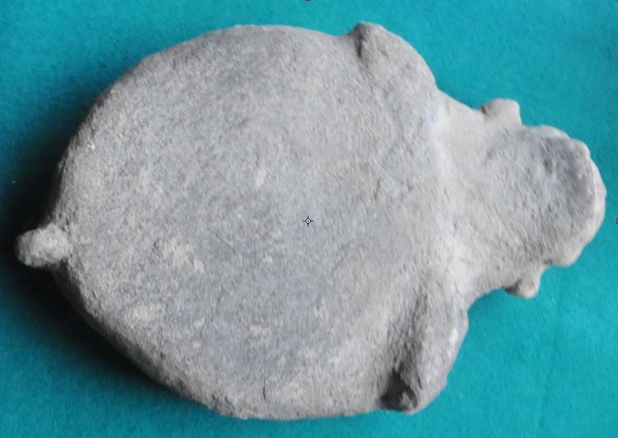

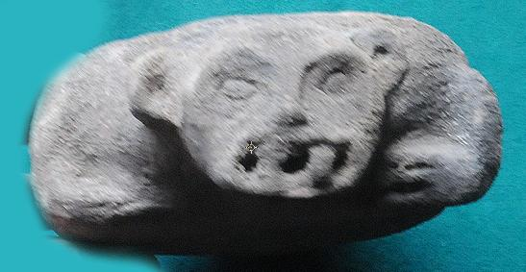

The Jaguar God of Terrestrial Fire is recognizable by jaguar ears, and jaguar fangs. He personifies the number Seven, which is associated with *Ak'b'al*(meaning “Night” which suggests “the Underworld”., he has been assumed to be the 'Night Sun' - the shape supposedly taken by the Sun ([Kinich Ahau](https://en.wikipedia.org/wiki/Kinich_Ahau)) during his nightly journey through the underworld - for reason of having the large eyes and filed incisor that also occur with the sun deity, and of sometimes evincing a *k 'in* infix. The deity's hypothetical aspect of a nocturnal sun (that is, a subterranean fire) should perhaps be connected to his proven association with terrestrial fire.